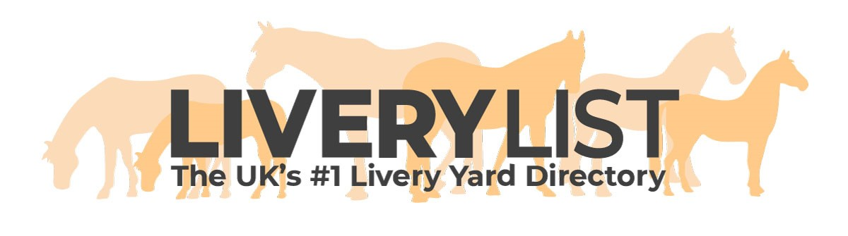
Reducing the Risk of Disease on Your Yard
The information below is a guide for people owning, managing, or keeping their horse at a private or commercial Livery Yard.

This information is supplied as guidelines only for the correct management procedures for your yard to reduce the likelihood of the spread and outbreak of equine infectious diseases (such as Strangles and Equine Influenza) on your yard.

In any such cases, it is important to seek the advice of a professional veterinarian as deemed necessary for the welfare of the affected horses and yard as a whole.

Why takes these steps?

As an equestrian professional, or a horse owner on a Livery Yard, you have a responsibility not only to your own equines, but also to any others in your contact or charge, to take the necessary precautionary steps to reduce the risk any outbreak of any illness or infectious disease. In the event of an outbreak, it is important to have procedures and knowledge in place to isolate any cases, and facilitate running the yard as best as possible during that time without risk of further contamination at your yard, or others.

Those in the equestrian sector open themselves to the risk of outbreak of equine infectious diseases in many scenarios which may not have even been considered-

- Taking on New Liveries
- Meeting Friends from other Livery Yards
- Attending Events (such as shows, lessons or riding club events)
- The hire of yard facilities to third parties or use of yard as an event venue
- Sharing tack, grooming equipment or tools
- Purchase of Second-Hand items such as tack or rugs

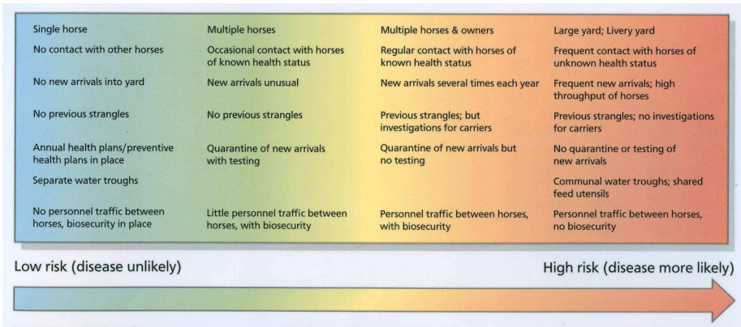

Dealing with Day to Day Prevention

- Check the Horse Over You should check your horse every day for signs of disease either as the owner, or as the yard owner or groom responsible for its day to day care. Basic signs would give an indication that a horse is unwell- dull coat, stiffness, coughs, unusual stance, rise in temperature, nasal discharge, loose stools and loss of appetite are all common signs that all is not well. Depending upon the severity of the signs, the horse should at the least be kept in for the day for observation, and a veterinarian called if necessary.

- Keep the Yard and Your Equipment Clean Although hard on large, busy yards, it really is important to keep on top of yard cleanliness as much as possible. Emptying wheelbarrows, sweeping up, poo picking, cleaning tools and equipment (such as feed bowls) are simple but effective ways to prevent outbreaks of illness and should be incorporated as daily or weekly routine tasks on the yard.

- Maintaining Smaller Herds Not possible with all yard set ups, but on larger yards there is the potential to minimise and isolate any potential outbreaks but having smaller herd groups that graze and are stabled together in separate blocks. This way, if an equine in one herd is affected by an illness or infectious disease, it would be easier to isolate within that smaller group of equines than, for example, a yard where all horses graze together.

- Attending Events If attending an event, there will be lots of unknown equines whose veterinary history is unknown to you. Be wary of horse to horse contact with unknown equines, shared transport and stabling. More on this in the section below.

- Equine on Your Yard There may be occasions- for lessons, schooling and the like- that third party users bring equines onto your yard. They could be known horses and riders to you, or could be complete strangers. It is important to draw a line between their use of facilities, and their contact with horses on your yard. Ensure any poo is cleared from facilities before they leave, and try to avoid direct contact with equines from your yard.

- Your Yard as a Competition Venue Your yard may be a venue for riding club events, shows or training and it is important to define the areas that can be accessed by visitors to the yard at these times. It is ideal not to allow any visiting equines or people directly onto the yard to prevent any potential contamination. It is advisable to put up signs and barriers to clearly mark areas permitted to be accessed by visitors and their equines. It should be ensured that, after the event, any areas accessed by other equines- such as paddocks or arenas used for events- should be completely cleared of poo and that disposed of immediately onto the muck heap.

- Sharing Tools, Tack, Equipment and Second Hand Items It is likely you know the veterinary history of equine on your yard, in which case less caution can be taken. However, if liveries are new, or unknown to you, you should be cautious about sharing items that will come in close contact with your horse (such as saddle cloths, bits, tack, grooming equipment), and should use your own where possible. If you purchase second hand items for your horse, be wary that it is likely from an unknown source and all second hand equipment should be thoroughly washed or cleaned as best as possible before use on your equine.

- Treat new Liveries Accordingly Any new equines to your yard should have a period of isolation before joining the main herd and yard. This is to rule out any potential diseases, and for the horse to be observed for any signs of disease or illness it may display before coming into contact with your other equines. More on this in the section below.

- Check What is Happening Locally Its always worth keeping an ear to the ground to keep in touch with what is happening in your local area. If you hear of outbreaks locally of infectious diseases, even just a possibility, caution should be exerted and limitations put in place. If there are cases locally it is advisable to put a stop to horses leaving the yard (for example for hacking or events), and for any new liveries to join the yard, or visiting equines, during that period. It is advisable to contact a local veterinarian to discuss the risks to your yard and seek their advice as to how to manage a local outbreak.

- Educate Your Horse Owners and Staff Any experienced horse owner or handler should be able to recognise the initial symptoms of disease and illness in equines. It is important that horse owners, and staff if applicable, are responsible to report any unusual activity or behaviours of horses on the yard to their manager or yard owner so that the necessary steps can be taken. It is advisable to ensure all horse owners know the potential signs of illness, perhaps by providing an information sheet, or a sign at your yard advising of the potential symptoms, and reminding them or preventative steps that can be taken on the yard as a precaution.

New Liveries at Your Yard

- Check the Paperwork Any responsible horse owner should check an equines paperwork before it enters the yard or is taken on as a livery. Not only for peace of mind relating to illness, but also to check the status of the insurance held. It would be advisable to check the Equine Passport at least for up-to-date vaccinations for Equine Influenza, if not tetanus as well. Copies should be taken of the Equine Passport Ownership page, ID page, and vaccination pages and kept on file.

- Isolation Period Any new equines should be isolated for at least 48 hours when arriving at a new yard- ideally for up to 7 days. This should ideally include a fresh, clean stable away from the main stable block, separate grazing with no access to the rest of the herd (or alternatively on ‘box rest’ for the duration), and separate equipment for mucking out and handling. Understandably not all yards are kitted out to cope with such a demand so this should be adapted as best as possible. The isolation period should be used to check the horse for possible symptoms of illness, checking the condition of stools, handling the horse for the first time (especially if on a yard based care package), and is also an advantageous time to worm the horse as well to eradicate any worm burdens at the same time.

- Introduction to the Herd Introduction to the herd should be managed calmly, and the existing liveries should be advised to check their own horses for signs of illness or sickness over the course of a week following integration of a new herd member.

Prevention Outside of the Yard

- Be Sensible at Events When attending with equines any events external of you yard, sensible precautions should be taken as it is unlikely you know many of the other equines attending. Do not allow nose to nose contact with other horses, do not share water buckets, feed buckets, tack or grooming equipment unless unavoidable. All tack and equipment should be cleaned – or at least wiped down- following return to the yard.

- Hired Stabling and Use of Facilities Some events require overnight stabling. It is recommended to only use temporary stabling which is clean, and clear of any previous signs of the last occupant (such as bedding, poo, hay etc). It is advisable to provide your own bedding, and to take along your own water buckets, feed buckets and hay nets as well as any equipment necessary for mucking out or care of the horse. The same applies for hire of facilities- such as arenas- which should be clear of poo or any other potential risks associated with cross contamination prior to your use.

- Transporting of Horses As above with hired facilities and stabling, any transport- particularly heavily shared transport such as professional transporters- should be free from poo, and provide a clean and sanitary environment for your horse to travel in. If you share your own transport with others, ensure you know the horse, or its history, well and be satisfied that you are not putting any potential illness at risk from close contact or use of your transport. After use, all transport should be thoroughly cleaned ready for the next use.

- Visiting Other Yards or Hacking Out With Friends If you’ve got liveries that meet to ride out or train with equines from other yards, or who visit other yards in the course of business or leisure it is important to remind them of the risks of cross contamination. Particularly advisable, as previously mentioned, is to keep on top of any local outbreaks or possible outbreaks to ensure these locations are avoided. After handling other horses, owners on your yard should ensure they wash their hands, and disinfect boots and equipment where practical.

Managing an Outbreak at Your yard

- Lockdown The first step should be to put the yard on lock down. No equines entering or leaving the yard for any reason- including hacking unless advised otherwise by a veterinarian, and no visitors unless absolutely necessary. Any equestrian professionals – such as vets, farriers etc- should be made aware of any outbreak prior to visiting the yard and arrangements altered accordingly. Ensure all horse owners are aware of the restrictions by the use of signs or other communication methods.

- Let Other Yards Know It is important, to prevent further local outbreaks, to advise other local equestrian venues know of your outbreak, or any potential outbreak. This will enable them to take the necessary steps to identify any horses on their yard who may have been subject to cross contamination from your yard or horses therein, and to take the necessary steps. Be honest- it is always best to send out a statement of fact sooner, rather than later, to prevent speculation.

- Isolation of the Infected Equine Any horse confirmed affected by any disease outbreak, or showing potential symptoms should be isolated from the rest of the yard immediately. This means stabled away from the main herd- ideally at least 40 metres away from other stabling- and kept in (or at least turned out in a small paddock away from any other equines) if possible. This is not always possible on smaller yards, in which case well defined ‘infected’ and ‘non infected’ areas should be set up to reduce cross contamination.

- Clean handling For the duration of isolation, any infected horses should have their own tools, equipment, handler and no contact with any other people or equines on the yard- not even sharing use of facilities unless absolutely unavoidable The handler should wash their hands prior to and after handling the horses to reduce cross infections with other equines on the yard, and ideally should wear gloves, overalls and different shoes in ‘infected’ zones. All horse owners on the yard should be prevented from contact with the horse, or entering the isolation zone.

- After the Outbreak Any horses which have had the disease should be returned to the main herd once the all clear is given from a qualified veterinarian following satisfactory results of any necessary tests. Any tools or equipment used during the period of isolations, as well as the stables and any facilities used or access by the horse should be full disinfected and scrubbed to prevent re-occurrence, allowing adequate time to dry fuller before re-use. The area used for cleaning, including drains, should then also be thoroughly cleaned themselves.

- Keep a Record It is important to keep a record of any outbreaks, affected horses and relevant details in the event of any future outbreaks, and for your own files.

IMPORTANT
This information as provided above is intended to provide guidance and areas for consideration for those intending to enter into such arrangements. Anyone proposing to enter into such a written agreement should take consideration and their own legal advice as to their particular circumstances.

© Livery List 2020

