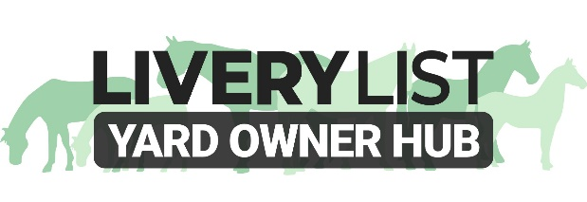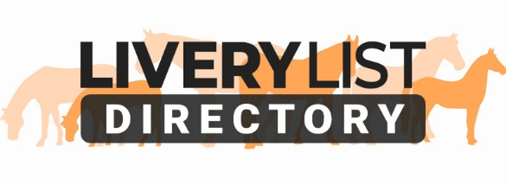
Equine Emergency Care Plan
If you keep your horse at livery, or even on your own premises, have you got an emergency plan if you or your horse are taken ill at short notice?
If you are out of action for any amount of time, taken ill, or in worst case that you pass away, it is vitally important that you have a plan of action for the suitable care of your horse or pony in your absence. It may seem dramatic but a rise of deaths and illnesses of horse owners during Covid raised this question for many yard owners who were left with horses and ponies to deal with, and no idea of the next of kin or who to turn to for the care and costs of the horse.
The same with your horse, you should have a plan of action in the event that there is an accident or injury, or again even death, and you cannot be reached. The yard should have the authority to deal with your horse on these occasions to ensure their needs, and your wishes, are met accordingly.

Care and Emergency Planning for Your Equine
Considerations:
- Make sure your yard has the details of your preferred vet, farrier, equine dentist or other equine professional who regularly attends to your horse. You should be provided with, or supply, a Horse Details Form to your yard
- If you are unable to care for your horse at short notice, ensure there is the possibility for cover from the yard, another livery, or even a friend or relative, but you must discuss your plans with your yard owner to ensure they are aware of any potential arrangements. You should also ensure the yard has contact details of these people.
- If you are using any paid services to help cover the care of a horse in your absence, you must ensure they’re fully insured and permitted to do so according by your yard owner.
- Ensure anyone who is likely to be caring for the horse is aware of the horses diet (feed, forage) and any specific requirements such as medication, supplements or allergies.
- Ensure anyone caring for the horse has access to keys, locks or codes that may be needed to access equipment.
- Keep an itinerary of your tools, equipment and belongings on the yard and, where possible, mark these clearly.
- Give your vet details of your yard and give them authority to contact the vet in your absence
- For all equines, there should be a clause in your contract allowing your yard to intervene with emergency veterinary treatment if deemed suitable (time constraints or in absence of the owner or inability to contact the owner)
- Ensure there are adequate contact details: a next of kin for you if you have an accident or are injured, and a next of kin for the horse if you cannot be contacted or to take over care of the horse if necessary.
- For all horses, regardless of age, but especially veterans it is important to consider their End of Life Options and discuss with your yard owner.
- Ensure there is a provision in your will for care of your horse in the event of your death, or a plan for its future. It is ideal to appoint a third party or the yard owner to deal with the sale of the horse if necessary, and to consider any livery costs or associated care costs in the interim.
- Make sure you periodically update these details and advise your vet, yard owner or other applicable person of any changes in these plans.

You can find a copy of the BHS Emergency Care Plan here:
equine-care-and-emergency-plan-v4.pdf (bhs.org.uk)

